REACT ASSIGNMENTS
Assignment 5:
AIM:
The aim of this exercise is to style React components using CSS Modules. The application displays multiple cohort details in card format with proper styling. The current status of each cohort is highlighted dynamically using different colours
IMPLEMENTATION
1. Created CSS Module
A CSS Module named CohortDetails.module.css was created to style each cohort card.
The following properties were applied:
- Border
- Rounded corners
- Margin
- Padding
- Fixed width
- Inline-block display

2. Imported CSS Module
The CSS Module was imported inside CohortDetails.js.
import styles from "./CohortDetails.module.css";

3. Applied Styling
The cohort information was enclosed inside a <div> and the CSS class was applied.
<div className={styles.box}>

4. Dynamic Status Color
Conditional rendering was used to display different colors based on the current status.
- Ongoing → Green
- Scheduled → Blue

1. CohortDetails.js
import styles from "./CohortDetails.module.css";

function CohortDetails(props) {

return (

<div className={styles.box}>

<h2>
{props.cohort.cohortCode} - {props.cohort.technology}
</h2>

<dl>

<dt>Started On</dt>
<dd>{props.cohort.startDate}</dd>

<dt>Current Status</dt>

<dd>
<h3
style={{
color:
props.cohort.currentStatus === "Ongoing"
? "green"
: "blue"
}}
>
{props.cohort.currentStatus}
</h3>
</dd>

<dt>Coach</dt>
<dd>{props.cohort.coachName}</dd>

<dt>Trainer</dt>
<dd>{props.cohort.trainerName}</dd>

</dl>

</div>

);
}

export default CohortDetails;

2. CohortDetails.module.css
.box {
width: 300px;
display: inline-block;
margin: 10px;
padding: 10px 20px;
border: 1px solid black;
border-radius: 10px;
}

dt {
font-weight: 500;
}

Result
The React application was developed successfully. A CSS Module was used to style the cohort cards, and conditional rendering was implemented to display the cohort status in different colors based on its value.
Output:
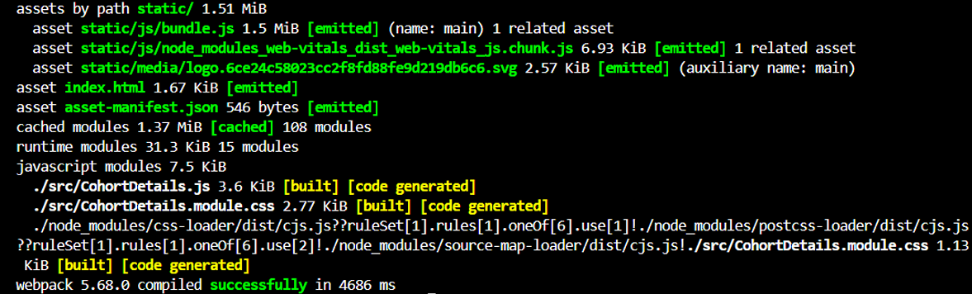
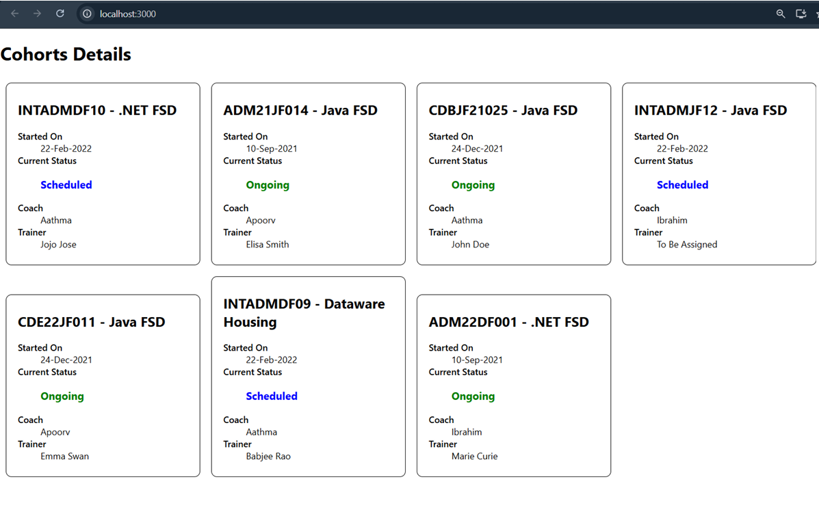
Conclusion
The experiment was completed successfully. CSS Modules were used to apply scoped styling to the React component, and conditional rendering was implemented to dynamically change the status color. This demonstrated the use of modular CSS and dynamic styling techniques in React.

